Machine Learning with Spark ML
Objective
Apply the concepts of Spark ML to build and evaluate a machine learning model using the bank.csv dataset. The goal is to predict whether a client will subscribe to a term deposit (binary classification).
- Data Loading and Initial Exploration:
  - Load the bank.csv dataset into a Spark DataFrame.
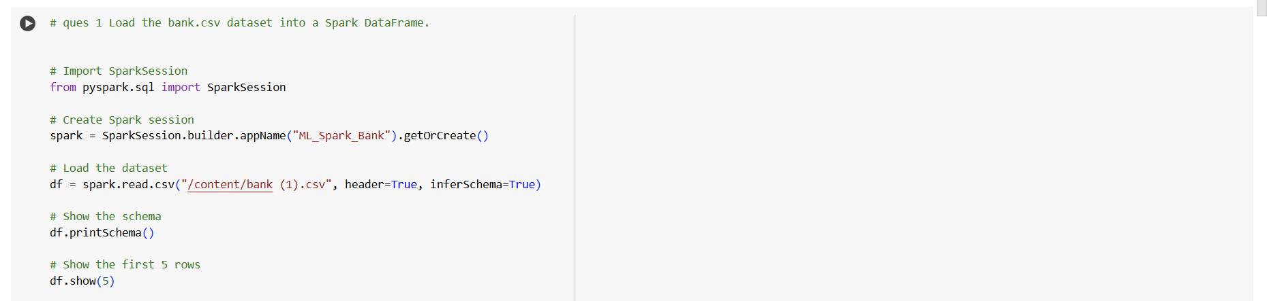

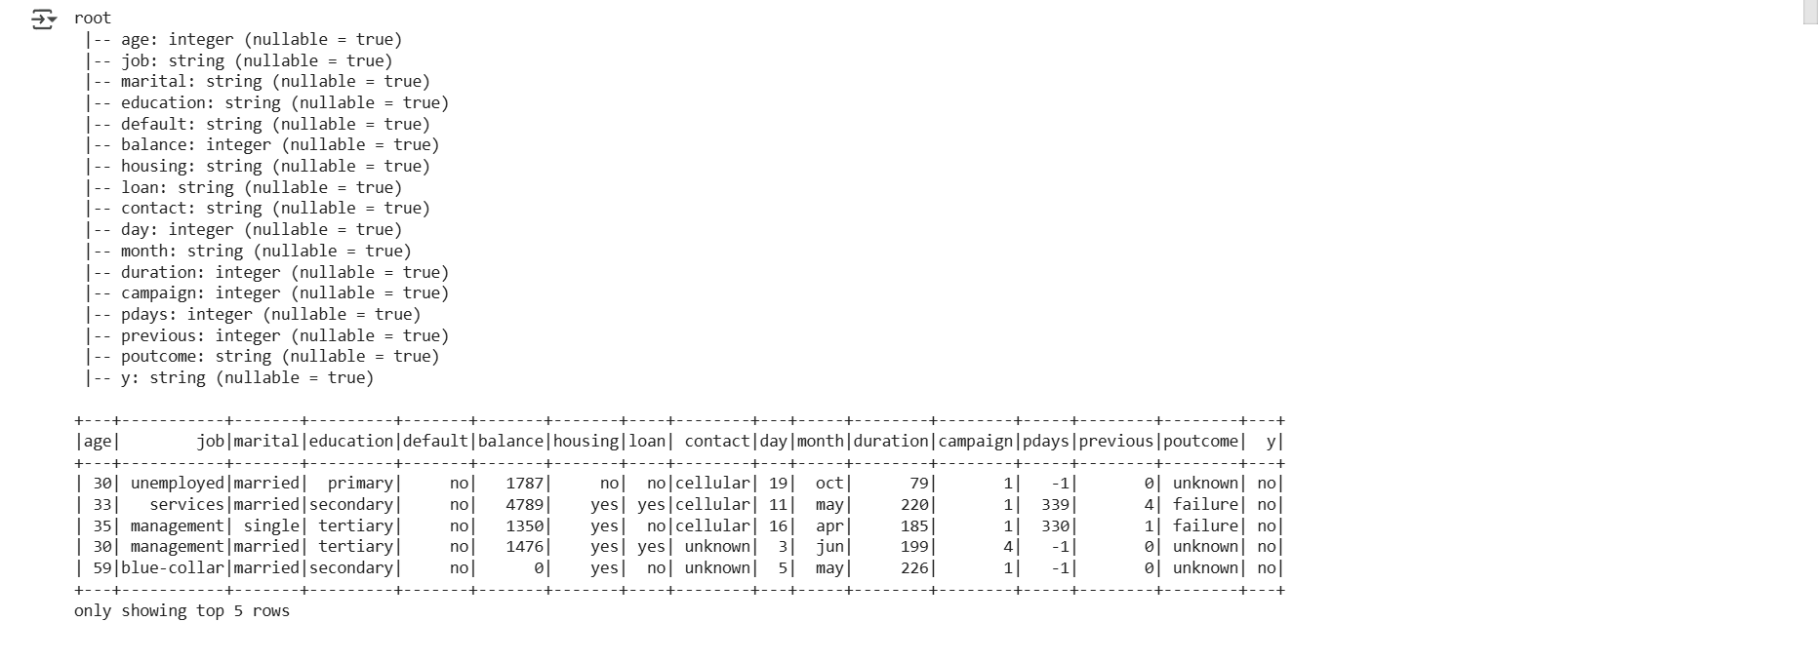
  - Perform basic exploratory data analysis (EDA) to understand the dataset. Display the schema and the first few rows.

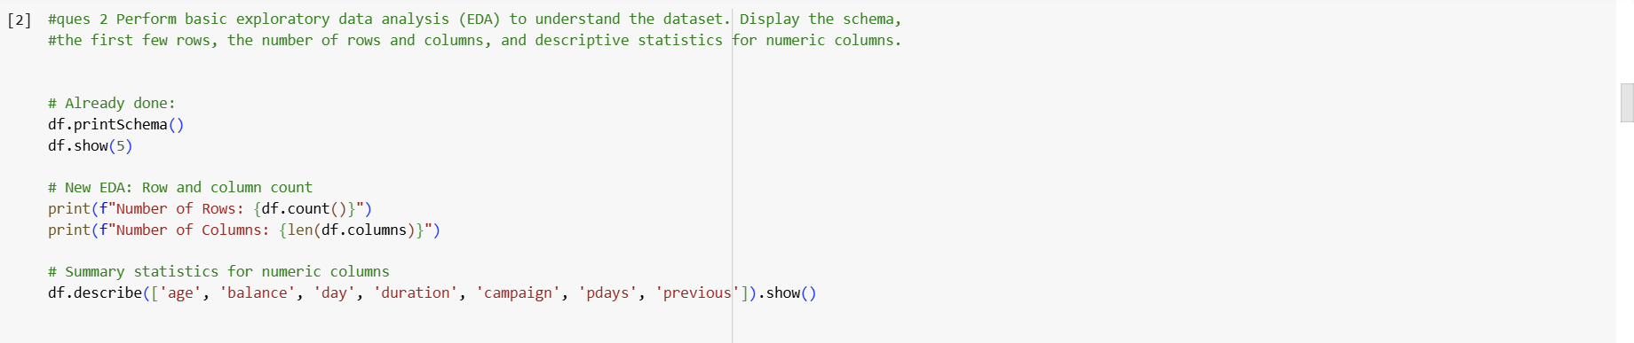

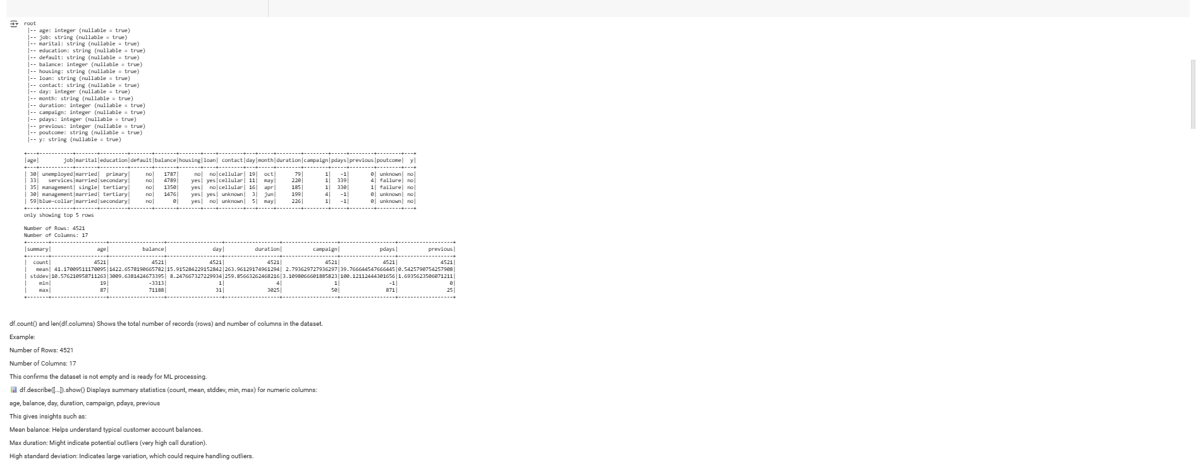
- Data Preprocessing:
  - Handle missing values in the dataset.
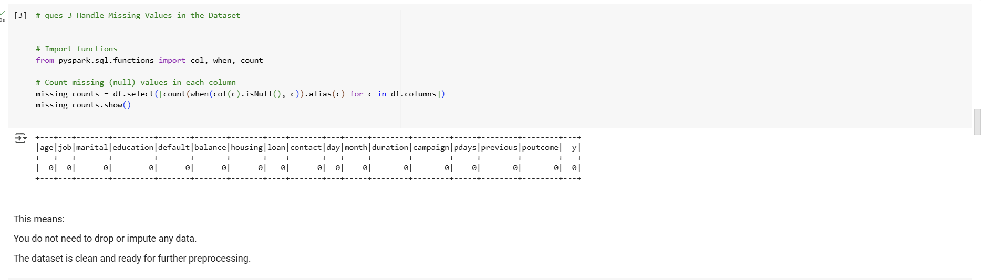
  - Handle Outliers in the dataset
- 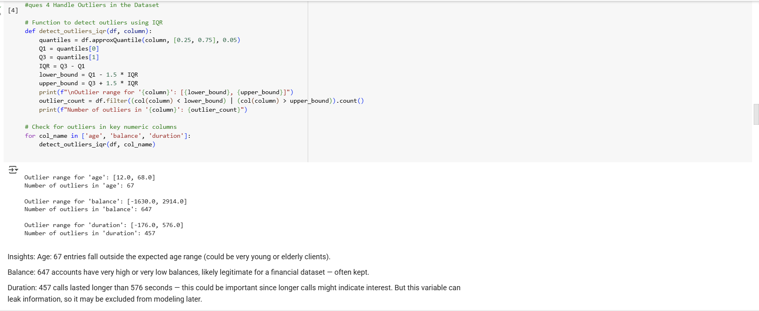
  - Convert categorical variables to numerical format using StringIndexer or OneHotEncoder.
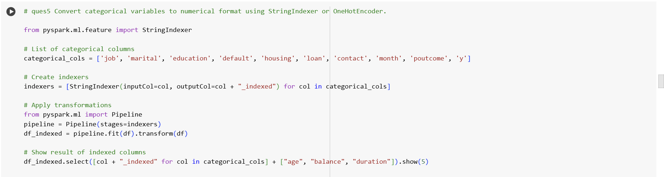

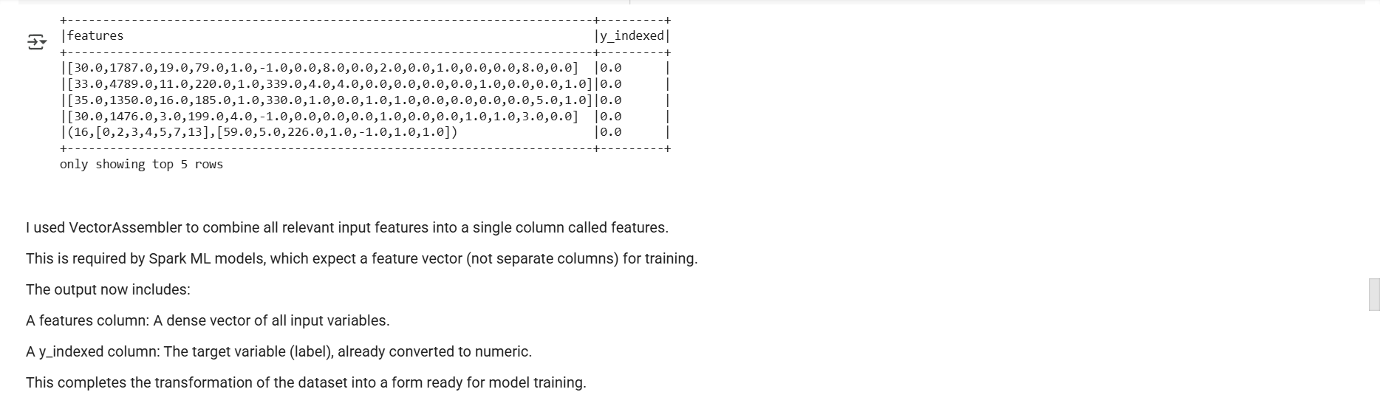
- Feature Engineering and Data Transformation:
  - Create a feature vector using VectorAssembler by combining all feature columns.

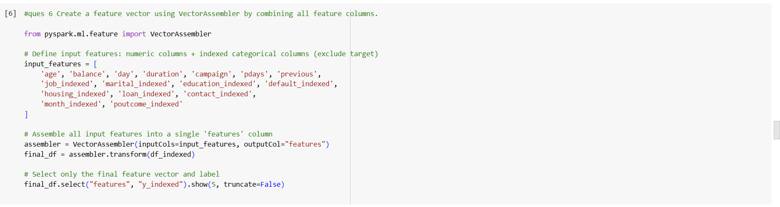

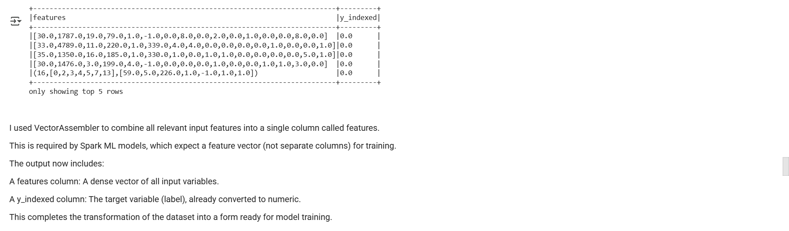
- Model Training and Selection:
  - Choose a classification model (e.g., Logistic Regression, Decision Tree Classifier) for predicting the subscription to a term deposit.
  - Split the data into training and test sets.
  - Train the model on the training dataset.
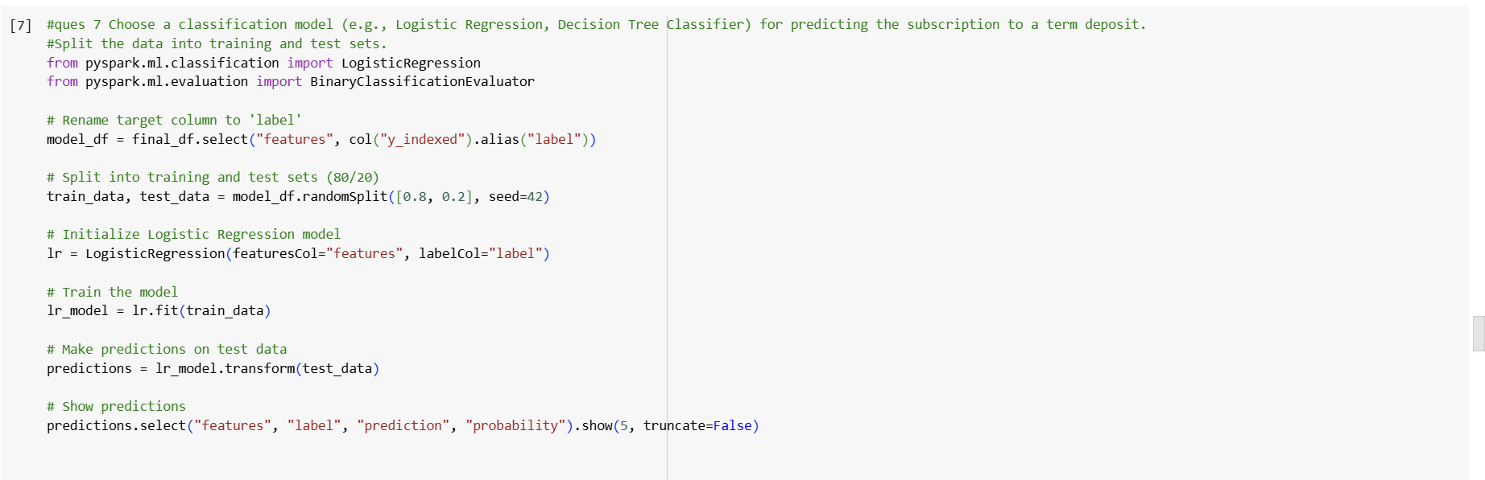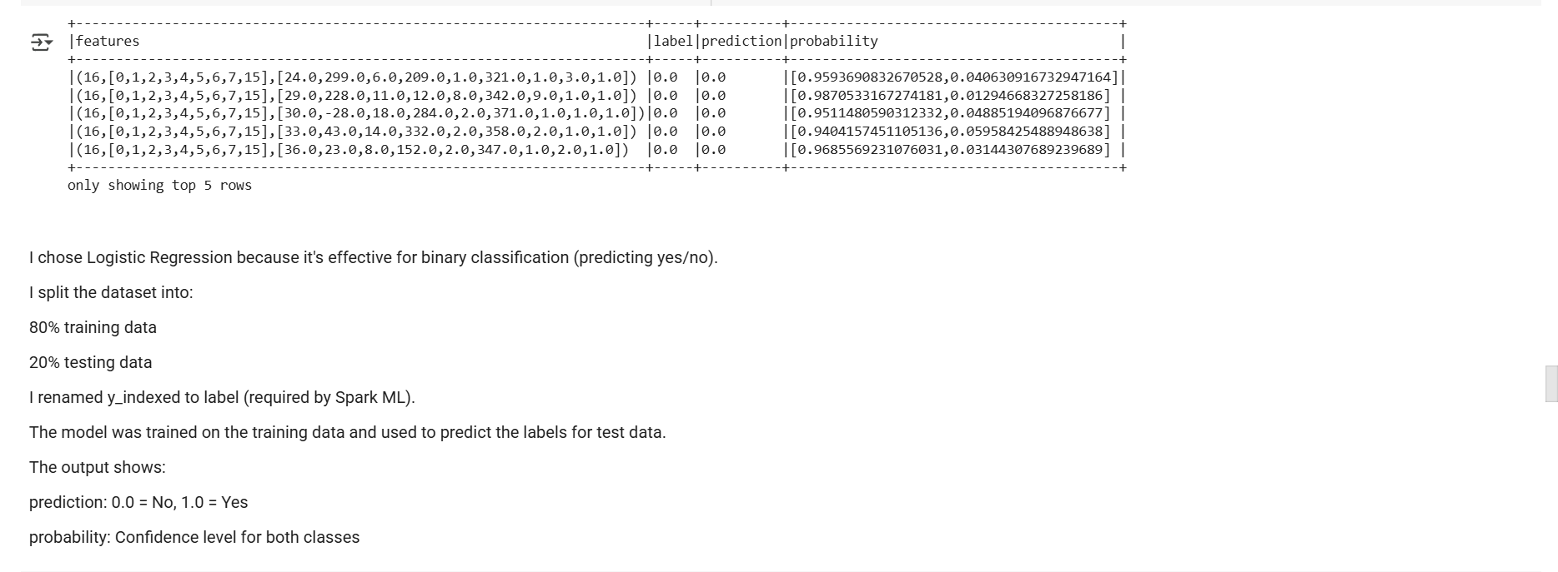
- Model Evaluation:
  - Evaluate the model on the test dataset using appropriate metrics.

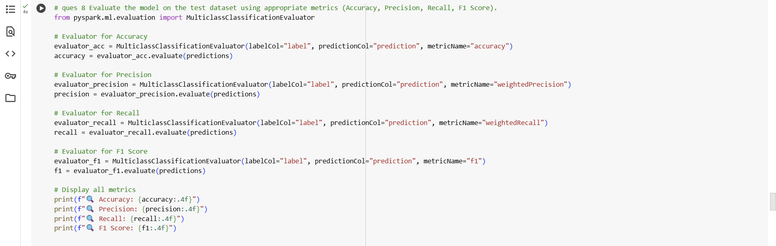

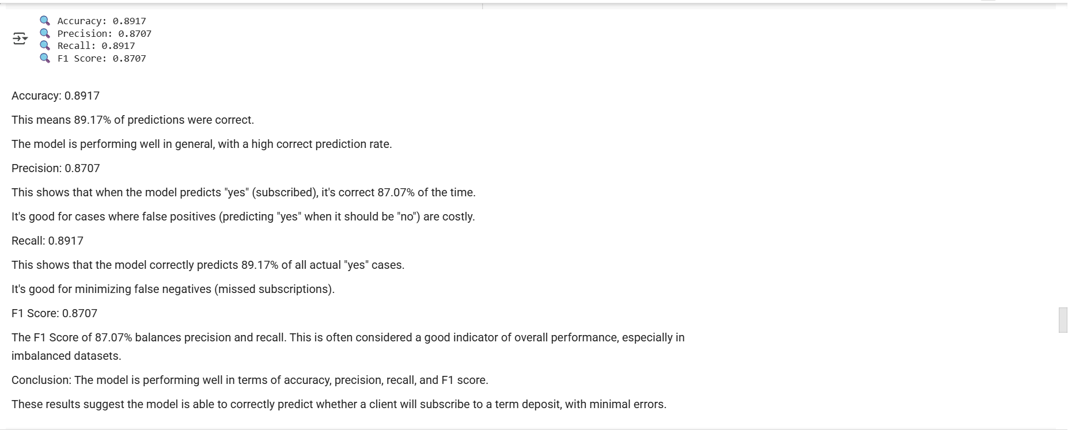
- Hyperparameter Tuning:
  - Perform hyperparameter tuning (using ParamGridBuilder and CrossValidator.)

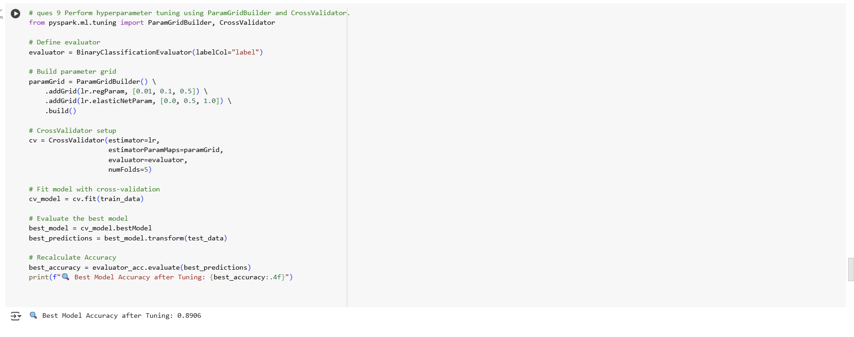

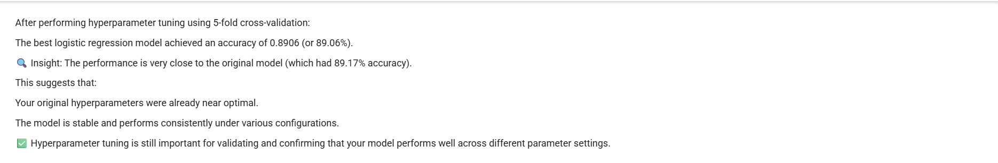
- Advanced Analysis:
  - Analyze the feature importances (if applicable) or coefficients of the model to gain insights into which features are most influential in predicting the outcome.

  - 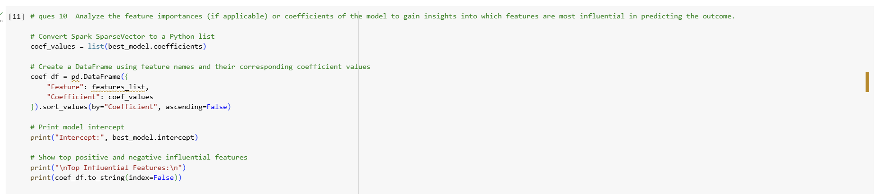

  - 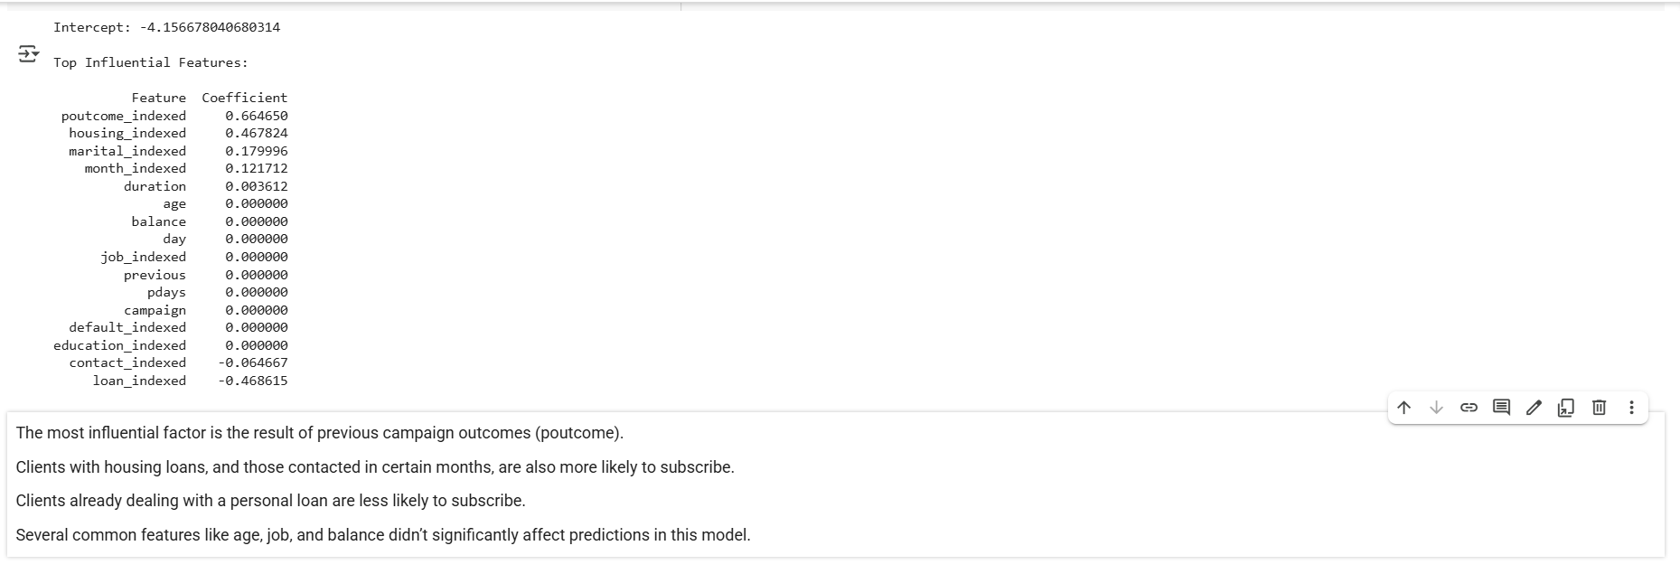
Submission Guidelines:
- You have the flexibility to perform the Spark data analysis either in Google Colab or in your local environment. Choose the option that is most convenient for you.
- If you choose to work in a local environment, please ensure you take screenshots of both the code and the output for each question. Make a copy of this doc file and include the screenshots in your copied document.
- If you opt for Google Colab, ensure to include the Colab file directly as part of your submission.
- Once your project is complete and your documentation is ready, please upload the document along with any other required files to the submission dashboard.
Colab link - Copy of Predictive Modeling for Banking Trends.ipynb

